Beetle Drive 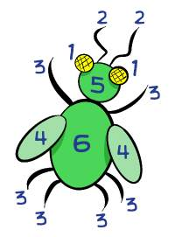

Moat Primary Parent Teacher and Friend Association (PTFA) invite you to attend our family friendly, fundraising event

Thursday 30th March 7pm at Moat Primarym

Light refreshments will be served

Lots of prizes to be won! Parent Teacher and Friend Moat Primary Parent Teacher a

Admission-Adults:£5

Friend Children:£3

Please call 02867721212 to book your space

